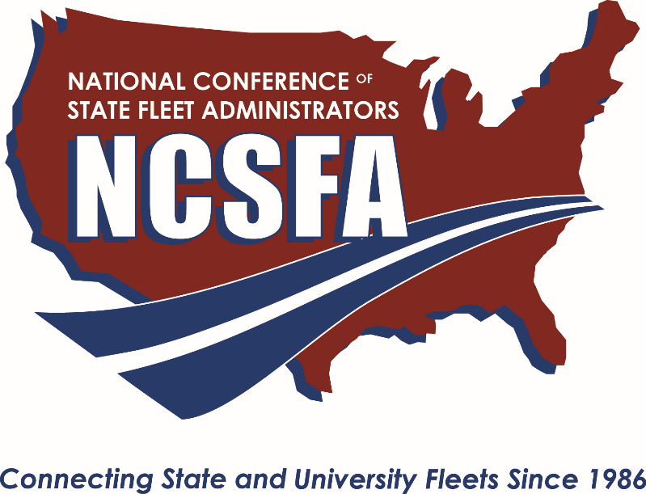

NATIONAL CONFERENCE OF STATE FLEET ADMINISTRATORS
2019 FLEET EXCELLENCE AWARD
Due: July 26, 2019
QUALIFICATIONS:
Using examples, please describe how the nominee has demonstrated leadership in his/her organization resulting in measurable cost reduction, the creation of new efficiencies, safety enhancements, or improved customer service.
The nominee must be the fleet director or equivalent of their organization. The nominee must be a member in good standing with NCSFA.

CRITERIA:
- Nominee has implemented a cost savings initiative and can document and describe measurable results
- Nominee has implemented a creative approach to solve problems, leading to improved efficiencies
- Nominee has implemented initiative to increase driver safety and can demonstrate results
- Nominee has implemented initiatives to increase customer satisfaction and can demonstrate results
- Nominee demonstrates the use of industry best practices that can be a model for other fleets

Please use this document to write your nomination. This nomination form and accompanying attachments can be submitted via online form located at https://ncsfa.memberclicks.net/Fleet-Excellence-Award. Please do not exceed 3 pages in your nomination.
Problem:
Briefly describe what problem the nominee attempted to solve in their organization:

Initiative and Results
Briefly describe the initiative led by the nominee and the accompanying results.

Leadership
Please describe the leadership displayed by the nominee. Also, note how the initiative can be a model for other fleets.

