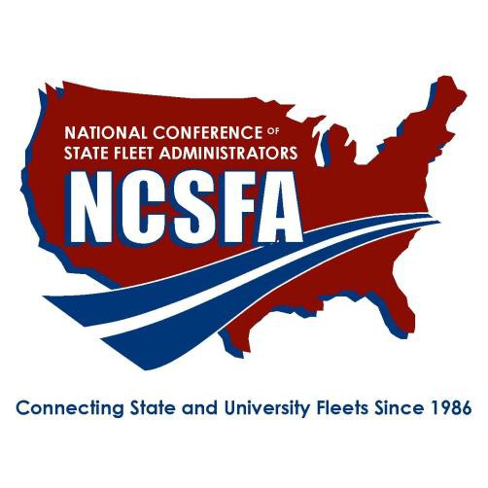

NATIONAL CONFERENCE OF STATE FLEET ADMINISTRATORS
2019 ENVIRONMENTAL LEADERSHIP AWARD
Due: July 26, 2019 Email to: info@ncsfa.net

NOMINATION FORM

Nominee:
State/Agency/Office:

ENTRY DETAILS:
- Submit a maximum of four (4) pages using the template below
- List total fleet size (by fuel and vehicle type)
- List percentage of total vehicles by size that are alternative –fueled, hybrid, electric, etc..
- Any additional attachments provided has support can be submitted during submission

The nominee must be an NCSFA member in good standing and illustrates good character consistent with ethical business practice.

QUALIFICATIONS:
Using specific examples, please describe in the pages below, how the nominee’s sustained contributions has improved their fleet’s environmental impact in terms of reduced greenhouse gas emissions, use of alternative fuel technologies, or reduction in dependency on petroleum-based fuels. Describe any written sustainability polices or programs in place.

CRITERIA:
Judges will evaluate the nomination utilizing the following four criteria:
- Significant advancement of the use or development of one or both of the following:
  - alternate vehicular fuels, vehicles or infrastructure, or;
  - electric or hybrid-electric vehicles or charging infrastructure
- Unique, innovative or creative in approach to deploy technologies listed above
- Established and achieved specific, measurable results
- Demonstrated the advancement of EPACT and DOE goals of improving air quality and reducing dependence on foreign oil

Total Fleet Size: __________

Percentage of total vehicles by size that are alternative –fueled, hybrid, electric, etc: ___________

Please answer the prompt

