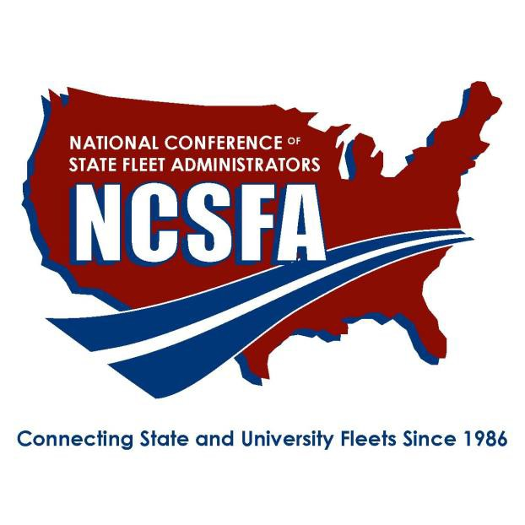
NATIONAL CONFERENCE OF STATE FLEET ADMINISTRATORS

2019 DISTINGUISHED SERVICE AWARD NOMINATION FORM
Please submit the nomination by July 26, 2019 to: info@ncsfa.net

Nominee:
State/Agency/Office:

Nominees must be an NCSFA member in good standing and illustrate good character consistent with ethical business practices. Using specific examples please describe how the nominee’s sustained contributions to NCSFA have furthered the organization’s mission and added to the quality of state and university fleet management.

Use the below criteria for guidance on what to include in the nomination:

In Leadership, nominee:
  - embodies and promotes NCSFA’s professional stature in the fleet community
  - seeks to improve NCSFA as a professional organization
  - serves as a mentor to other fleet professionals
  - models leadership traits that empower others

In Knowledge and Information Sharing Abilities, nominee:
  - provides regular and constructive feedback to NCSFA member requests
  - develops awareness of fleet industry problems and engages in open dialog with other NCSFA members
  - uses fleet experience and management skills to enhance the abilities of peers

In Distinguished Service and Dedication, nominee:
- has served as an effective contributor during NCSFA events

In Character, including ethics and commitment to diversity, nominee:
- creates and maintains a positive work culture and climate; uses ethics in decision making; and understands the benefits and challenges of a diverse workforce
- embraces positive change and promotes “Best Practices”

Please describe how the nominee’s sustained contributions to NCSFA have furthered the organization’s mission and added to the quality of state and university fleet management:

